Step 01- Read the article -Strategy and Society: The Link Between Competitive Advantage and Corporate Social Responsibility (January 2007). [Harvard business review](https://www.researchgate.net/journal/0017-8012_Harvard_business_review) 84(12):78-92, 163. Uploaded on D2L

Step 02- Understand the below three result diagram well from that article

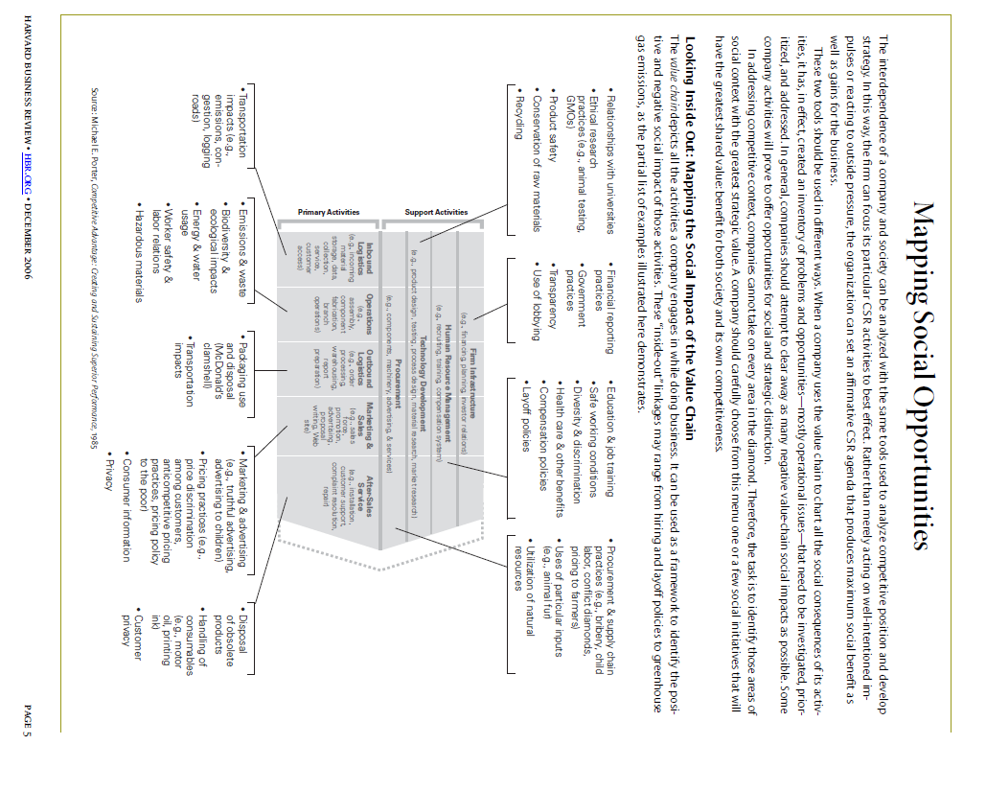

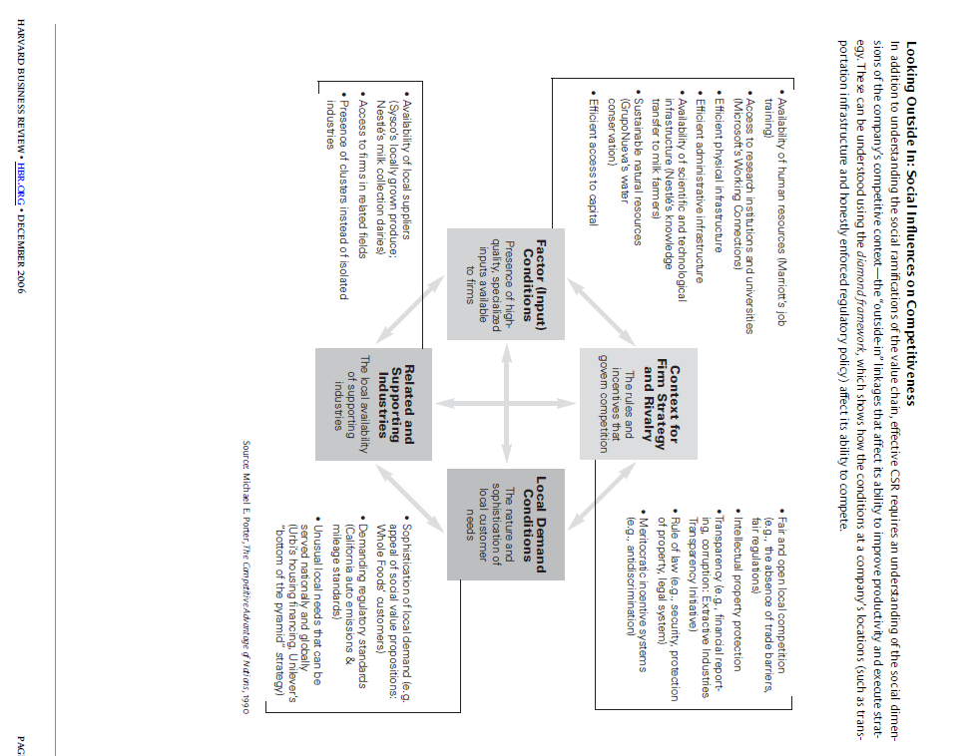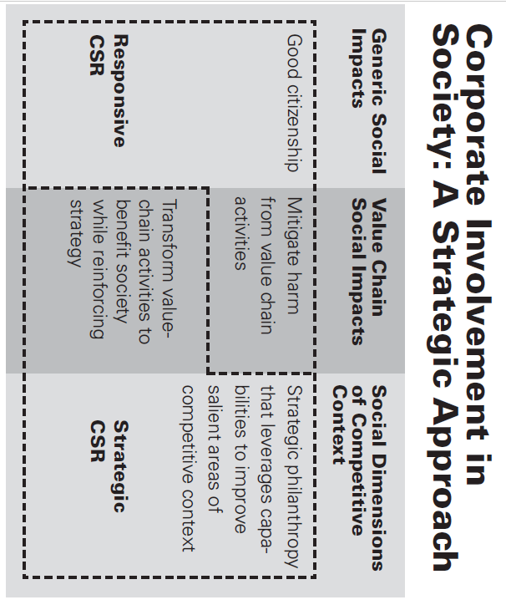

STEP 03- Download any recent sustainability report of any organization. Just search for “Sustainability Report” as pdf in search engine you will get sustainability report of almost all fortune 500 firms.

STEP 04- Identify the activities they are doing for sustainability and sync it with the first two diagrams.(activities they are doing for society and environment falls under which category of diagram 1 and 2 above)

STEP 5- Make a summary analysis report using the digram 3 above

Step 6- Submit on D2L

**BELOW IS A SAMPLE REPORT (DO NOT SELECT THE SAME COMPANY MENTIONED IN THE SAMPLE)**

**https://about.ikea.com/en/sustainability/sustainability-report-fy20**

